**Agent:**

An agent is entity that perceives its environment,

able to perceive the things around it,

and act on that environment in some way.

**Actions:**

Returns set of actions that can be executed in state (s).

State (s)

Action (a)

Result(s, a) returns state resulting from performing action a in state s.

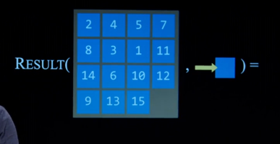

Output, new state.

**Transition model:**

Description of what state results from performing any applicable action in any state.

**State space:**  
Set of all states reachable from initial state by any sequence of actions (all possible outcomes?)

**Goal test:**

Way to determine whether a given state is a goal state (wherever you want to reach).

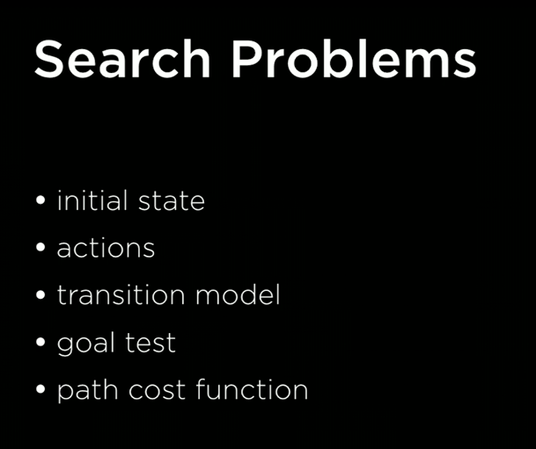

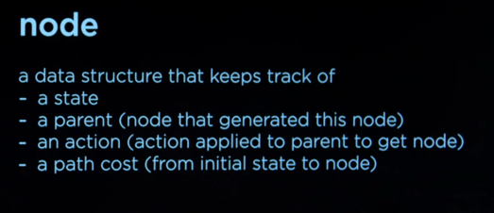

Parent (state before us)  
  
Frontier: Whatever is there to explore.

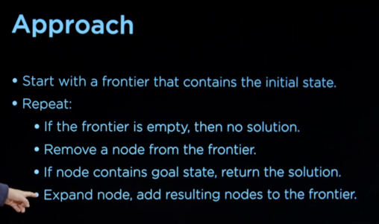

Look at neighbours of nodes.

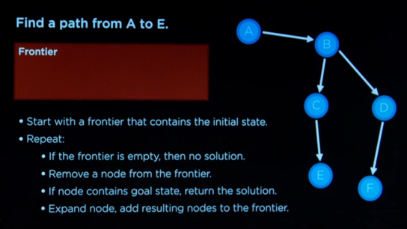

Heuristic function h(s) Ignoring the walls which seems closer

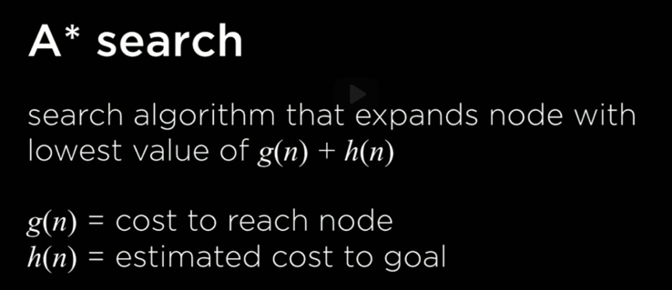

Also considers how long it took to get there